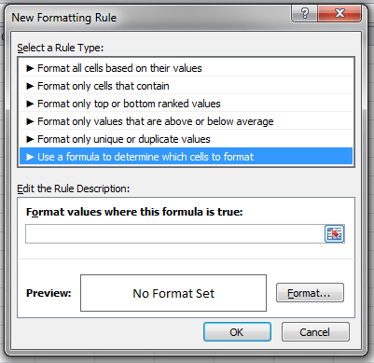

With the addition of Conditional Formatting we now support almost all of the functions that are used in excel. In version 7.4 we made several enhancement to improve your capabilities. You can now use the conditional formatting with dropdowns having currency and/or decimals, fixed accuracy with Between Operator and we now support formula type.